**Project Report  
  
Part 1: Introduction**

In an era when climate change offers severe dangers to our economy and the environment, understanding the dynamics of energy usage and how it influences CO2 emissions is critical. This research tries to disentangle the intricate relationship between global trade in fossil fuels and the resulting carbon emissions through a strategic analysis of the existing situation and predicted trends. We evaluate data on import-export activity from various countries to assess their percentage of global emissions and investigate potential transitions to renewable energy sources. A significant emphasis is placed on renewable energy's contribution to climate change mitigation, with Iceland serving as a case study for effective energy transition. This research gives a full grasp of the shift's potential and limitations.

**Part 2: Data Source Description**

**Source of Dataset**

The project's data set will include historical import-export statistics for fossil fuels broken down by nation, the kinds of fossil fuels that are traded, and the associated CO2 emissions. Data on Iceland's carbon reduction policies and strategies will also be included. The primary sources of data will be Our data in world, Kaggle, hum data.

<https://ourworldindata.org/fossil-fuels>  
<https://www.kaggle.com/datasets/ggsri123/co2-emissions-from-fossil-fuels>  
<https://en.wikipedia.org/wiki/List_of_countries_by_renewable_electricity_production>

**Characteristics of Datasets**

<https://ourworldindata.org/fossil-fuels>

Global historical data on the production of fossil fuels, their use in the production of electricity, and their contribution to CO2 emissions

Period: 1995–2022

Data is divided by kind of fuel (production of oil, gas, and coal).

Global totals and breakdown by key nations and regions are included in the data.

Give comprehensive historical global fossil fuel import-export data.

Describe the various forms of fossil fuels (coal, oil, and natural gas) and the trading of these resources.

<https://www.kaggle.com/datasets/ggsri123/co2-emissions-from-fossil-fuels>  
Dataset with information on global CO2 emissions from fossil fuels between 1751 and 2017

Quantities of carbon dioxide emissions expressed in million metric tonnes

Information obtained from the Carbon Dioxide Information Analysis Centre (CDIAC)

Divided into groups according to the type of fuel (solid, liquid, gas, flaring, cement) and by country.  
<https://en.wikipedia.org/wiki/List_of_countries_by_renewable_electricity_production>

List documenting electricity generation from renewable energy by country

Focus on non-hydroelectric renewable energy sources.

Measured in terawatt-hours (TWh) per year.

Has data for ~190 countries' non-hydroelectric renewable energy production

<https://www.iea.org/countries/iceland>

Provides energy data and statistics specific to Iceland.

Includes data on energy supply, electricity generation, energy policies, and metrics like CO2 emissions.

The timespan of data covers last several decades with some graphs going back to 1971.

Data is quantified using a variety of units including Mtoe (million tons of oil equivalent), GWh (gigawatt-hours), and MtCO2 (million tons of CO2)

Breakdowns by fuel types like hydro, geothermal, oil, coal, natural gas

**Data Cleaning Steps**

Exclude columns containing over 65 -75% missing values.

Check for and remove duplicate rows or entries in the dataset  
Eliminate and fill in values after affirming the values in the dataset is not precise.  
Eliminate observations where the year value falls outside the specified range mentioned in the data source.

Ensure that data types (e.g., numeric, string, date) are consistent with the expected format. Convert data types as needed.  
Merging different datasets to get a required data column together.

Check for inconsistent values that don't make sense in the context of the data.

**Key audience**

The Target Audience Policymakers, who oversee developing environmental and energy policy, need data-driven insights to make informed decisions about carbon emissions, fossil fuel trade, and climate targets. This project intends to offer them useful information to aid in the creation and implementation of good policies.

**Part 3: Data Visualization and Storytelling**

**Strategic Question 1:**

**What is the relationship between fossil fuel import-export activity and a country's CO2 emissions?**

**Descriptive:**

**1). What is the current relationship between the imports, exports, and CO2 emissions of fossil fuels for various nations?**

In brief, the above depicted images we see that there is an upward trend in both imports and exports of fossil fuels coal, gas, and oil from 1995 to 2022. Coal and oil show substantial growth in imports, indicating that these fuels are major contributors to the countries' energy needs. Gas imports and exports have also increased, though at a steadier, more moderate rate.

While the images do not directly show CO2 emissions, the increase in fossil fuel imports suggests a potential rise in CO2 emissions, assuming these fuels are combusted domestically. Export data indicates that some countries are major suppliers of fossil fuels, which could mean they are exporting the associated emissions to the importing countries.

The relationship between fossil fuel trade and CO2 emissions is implicit: higher imports typically signal higher consumption, leading to increased emissions. Conversely, higher exports may imply that the exporting country is affecting the importing country's emission levels.

**Predictive:**

**2). Can we forecast future CO2 emissions variations based on anticipated changes in fossil fuel imports and exports?**

Analysis of CO2 Emission Forecasts:

The trend of CO2 emissions from 1994 onwards shows a consistent increase, aligning with the growth in fossil fuel consumption. This data is crucial for establishing a baseline for future predictions. The projected CO2 emissions, extending to 2028, suggest a continuation of this upward trend. The forecast, represented by a dashed line, is extrapolated from past emissions data and current fossil fuel trade patterns. A key aspect of the forecast is the uncertainty range, indicated by the shaded area around the projection line. This acknowledges the potential variances due to unforeseen factors.

If the current trajectory of fossil fuel trade continues, it is anticipated that CO2 emissions will follow the forecasted path. However, this is a predictive model subject to change with shifts in global energy policies, market dynamics, and technological advances in clean energy.

**Prescriptive:**

**3). What specific policy measures can a government put in place to reduce the impact of fossil fuel import-export activities on CO2 emissions?**

To mitigate the effects of import-export operations using fossil fuels on greenhouse gas emissions, policymakers may choose to explore a variety of solutions that fall into the following categories:

1. Policies for Energy Transition:

- Renewable Energy Incentives: Financial assistance and tax breaks for renewable energy initiatives that promote the growth and application of hydroelectric, solar, and wind energy.

- Carbon Neutral objectives: To encourage the economy to adopt sustainable practices, legally binding carbon neutrality objectives should be set.

2. Financial Toolkits:

- Carbon Tax: By placing a price on greenhouse gas emissions, the introduction of a carbon tax will increase the cost of emitting CO2.

- Green Investment: Setting aside money to promote the development of green technologies to increase energy efficiency and lessen reliance on fossil fuels.

3. Regulatory Actions:

- Strict emission regulations should be put in place for businesses and automobiles in order to lower the carbon intensity of fossil fuels.

- Cap-and-Trade Systems: Implementing a program to set emissions limits and develop an emission permit market.

4. Public Instruction and Involvement:

- Awareness Campaigns: Organizing public education initiatives to raise knowledge of the advantages of renewable energy sources and CO2 emission-reducing techniques.

- Stakeholder Engagement: Including corporations, non-governmental organizations, and communities in energy policy decision-making processes.

5. Increasing the Variety of Energy Sources:

- Alternative Fuels: Encouraging the use of hydrogen, biofuels, and synthetic fuels for industry and transportation.

- Decentralized Energy Systems: Promoting the use of distributed energy resources and microgrids to lessen the strain on the grid and boost system resilience.

6. Infrastructure Development: - Energy Efficiency Upgrades: Putting money into making buildings, transportation systems, and industrial processes more energy-efficient.

- Public Transit Expansion: Increasing the number of public transport systems to lessen the dependency on private automobiles.

**Strategic Question 2:**

**Which countries contribute significantly to global CO2 emissions through their fossil fuel trade, and what sorts of fuels are most to blame?**

**Descriptive:**

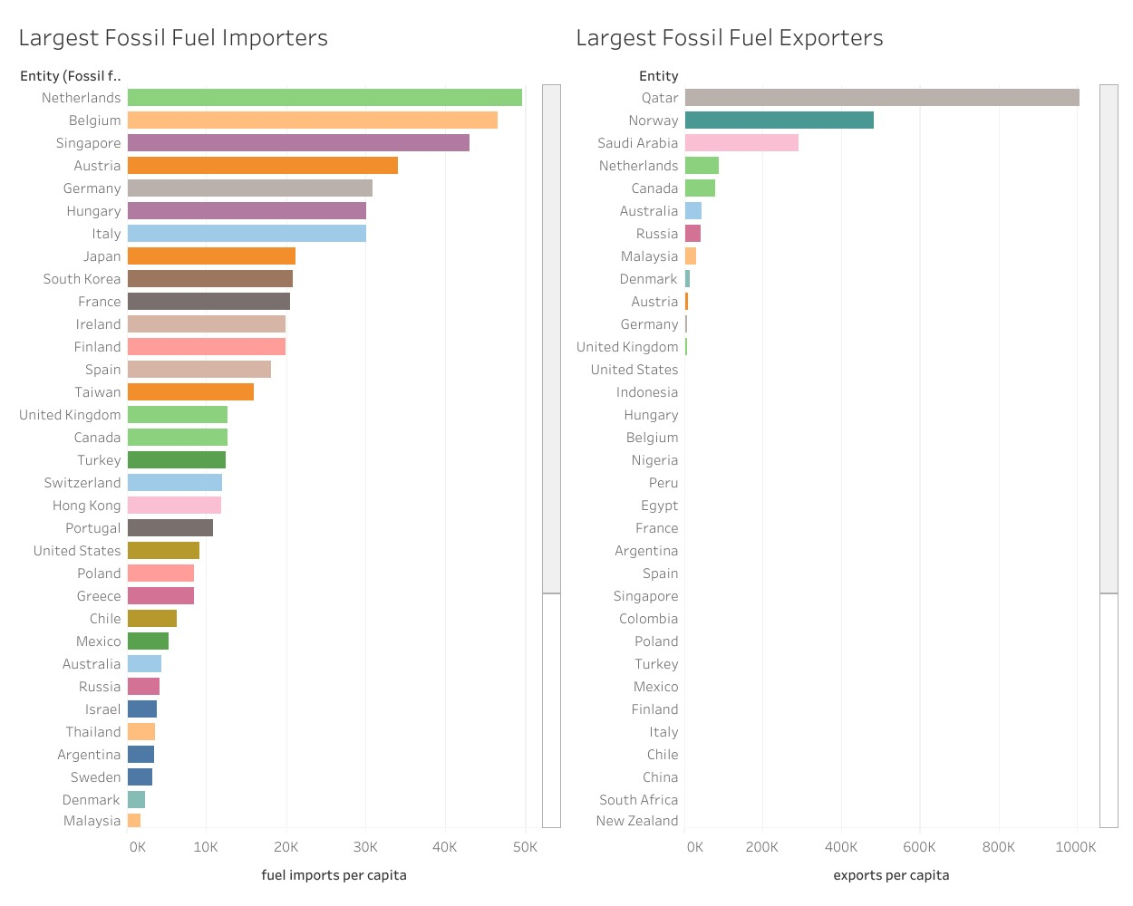 **1). Which countries contribute the most to global CO2 emissions from fossil fuel imports and exports?**

Importers of Fossil Fuels: The data visualization makes it clear which nations are the biggest importers of fossil fuels per person, with the Netherlands, Belgium, and Singapore at the top. The bar graph shows that despite their smaller sizes, these countries import a lot of fossil fuels per person, which may be related to their status as hubs for energy transit or to their deficiency of domestic energy resources.

Fossil Fuel Exporters: On the other hand, the second graph ranks the top exporters of fossil fuels per capita, including Norway and Qatar. Their economies are heavily weighted in favour of the energy sector, which drives up the price of fossil fuels globally.

CO2 Emissions: When comparing these numbers to CO2 emissions per capita, as shown in the third chart, the United States and Qatar stand out as having significant carbon footprints due to their high domestic consumption and fossil fuel exports.

While countries with high fossil fuel imports per capita, such as the Netherlands and Belgium, contribute to global CO2 emissions, it is the countries with high per capita exports, like Qatar and Norway, that play a pivotal role in the fossil fuel industry. Moreover, nations with significant CO2 emissions per capita, like Qatar and the United States, are key contributors to global emissions, influenced by both their export activities and domestic consumption patterns.

**Predictive:  
2). Based on their trading activity, can we predict which countries will become big contributors to global CO2 emissions in the future?**

The provided CO2 emission forecast by country, alongside trade data, allows for a predictive analysis of future contributors to global CO2 emissions.

Key Contributors: -

China: China is expected to continue to be a top emitter of CO2 due to its increasing trajectory in emissions. This trend is further supported by its large industrial base, coal-based economy, and expanding energy requirements.

United States: Historically, the United States has been a significant CO2 emitter. Despite a stabilization in the growth rate of its emissions, its large economy and energy consumption patterns are expected to make it a significant contributor.

India: The country's emissions are rising and are expected to continue rising because of its fast-growing economy and rising energy needs.

Russia and Japan: Because of their industrial activities and energy export profiles, they continue to be major players even though their emissions seem to be somewhat stable.

Trade Activity Impact:

Countries with increasing fossil fuel import and export activities, such as China and India, are positioned to become even larger contributors to global CO2 emissions.

As these countries develop economically, their energy consumption, fueled by imports, may rise, leading to higher emissions unless mitigated by renewable energy investments or efficiency improvements.

Conclusion:

The projection indicates that nations with expanding economies and energy needs, particularly those increasing their fossil fuel trade, are likely to become more prominent in the global emissions landscape. While China and the U.S. are expected to maintain their lead, India’s growing emissions present a notable concern for future CO2 levels. These predictions underscore the importance of proactive international policy measures and energy strategies to manage the anticipated rise in global emissions.

**Prescriptive:**

**3). How can countries shift from high-emission fuels to cleaner alternatives, and what assistance would they require?**

Techniques for the Countries for Energy Transition:

Diversification of Energy:

It is imperative for nations to broaden their energy mix by integrating sustainable energy sources like hydroelectric, solar, and wind power. Expanding the clean energy infrastructure is necessary to move away from high-emission fuels.

Adoption and Innovation of Technology:

-It is essential to adopt new technologies for clean energy generation and energy efficiency. The shift can happen more quickly if research and development in these fields are supported.

Policy Adjustment and Motivation:

- The adoption of beneficial policies, such as cap-and-trade systems or taxes that penalize high emissions, can encourage the transition to cleaner energy sources. Subsidiaries for renewable energy can also be implemented.

Global Cooperation:

- International cooperation is required to make technology transfer easier, particularly for developing nations without the financial means to invest in cleaner energy sources.

Education:

- To maintain the shift, local knowledge of renewable energy technologies must be developed through training initiatives and educational campaigns.

Assistance Needs:

Technical assistance is needed. This includes knowledge of how to phase out fossil fuel infrastructure and plan and implement renewable energy projects.

Financial Assistance: Developing nations, more than others, need financial assistance to get over the initial steep costs associated with switching to renewable energy sources.

Policy Guidance: It is advantageous to receive assistance in creating regulations and policies that effectively support the energy transition.

Market Access: It is critical to provide developing nations with avenues to enter international markets for green technology and renewable energy products.

In conclusion, countries require extensive support in the areas of technology, finance, policy, and education to facilitate the global transition from high-emission fuels to cleaner alternatives. Developed countries might be at the forefront of innovation and investment, but developing nations need a lot of help to catch up with the change. The global transition to sustainable energy practices will be greatly aided by international cooperation, focused aid, and capacity building.

**Strategic Question 3:**

**What distinct techniques and policies has Iceland implemented to cut its carbon emissions, distinguishing it from other countries?**

In the graph we see that among the top renewable energy consumers Iceland has been on the top of the list for consuming renewable energy since 2000. This has been described further in the following questions,

**Descriptive:**

**1). What unique renewable energy sources has Iceland used to cut its carbon emissions, distinguishing it from other countries?**

The composition of renewable energy in Iceland:

Leading Renewable Energy Sources:

The diagram illustrating a substantial portion of Iceland's energy mix shows that geothermal and hydroelectric power account for most of the the country's production of renewable energy. The bulk of the nation's renewable energy consumption falls into the "Wind, solar, etc." category, which includes geothermal energy because of data categorization, thereby validating Iceland's exceptional utilization of its geothermal resources.

Small-scale contributions: Waste and biofuels are minor additions to Iceland's renewable energy mix, serving to supplement the main sources.

Use of Fossil Fuels Is Limited: Iceland’s dedication to sustainable energy is demonstrated by the low amount of oil used in comparison to renewable sources.

Iceland is unique among nations in that it uses geothermal energy for both heating and electricity, whereas many other countries rely more heavily on conventional renewable energy sources like solar and wind.

In summary, Iceland's usage of renewable energy is distinct because it makes extensive use of geothermal energy, which is complemented by hydroelectric power. Because of this combination, Iceland has been able to attain low carbon emissions and become a global leader in the use of renewable energy.

**Predictive:**

**2). Given Iceland's current trajectory, can we estimate future trends in renewable energy production and the related reduction in carbon emissions?**

Over the years, Iceland has steadily increased its percentage of renewable energy, with geothermal and hydroelectric power accounting for a sizable portion of this total.

Based on the energy sector forecast for Iceland, the use of renewable resources is expected to grow significantly, potentially surpassing current levels of share in the energy mix. The projections' upward trajectory and the range of the confidence interval serve as evidence for this. This increased reliance on renewable energy sources is expected to contribute to a corresponding decrease in carbon emissions as Iceland's commitment to sustainability grows, in line with the nation's environmental objectives and its standing as a leader in sustainable energy practises.

In conclusion, it is reasonable to expect continued expansion in the production of renewable energy given Iceland's established pattern of using renewable energy and the projected growth. This pattern is probably going to help further cut carbon emissions, which will strengthen Iceland's standing as a pioneer in sustainable energy methods.

**- Prescriptive:**

**3). What concrete recommendations can be drawn from Iceland's unique approach to renewable energy and carbon emissions reduction, and how can these be used globally?**

Recommendations Derived from Iceland's Energy Approach:

Leverage Local Natural Resources: Like Iceland's use of its geothermal and hydroelectric potential, countries should recognize and capitalize on local and natural renewable resources.

Invest in Sustainable Infrastructure: As shown by Iceland's hydroelectric dams and geothermal plants, infrastructure development is essential to facilitating the global adoption of renewable energy.

Support for Renewable Energy Policies: - By putting in place policies that promote the production and use of renewable energy, including incentives for both producers and consumers, we can imitate Iceland's success.

Innovation and Research Focus: Promoting innovation in energy efficiency and renewable technologies can result in developments akin to those observed in Iceland's energy industry.  
Collaboration between Public and Private Sectors: - Encourage public and private sectors to work together to finance and develop renewable energy projects.

Engagement with the Public and Education: Promoting the use of renewable energy and educating the public about its advantages are essential, as demonstrated by Iceland's public support for environmentally friendly behaviors.

Carbon Neutrality Objectives: - Setting challenging but attainable carbon neutrality objectives can give energy policy and business practices a clear path forward.

Replicability and Adaptability: Despite the uniqueness of Iceland's model, its guiding principles can be applied anywhere in the world by modifying them to suit local conditions and resource availability.

Iceland’s approach offers concrete steps for other nations to follow in increasing renewable energy usage and reducing carbon emissions. By tailoring these recommendations to their specific environments, countries around the world can make significant strides toward a more sustainable and low-carbon future.

**Conclusion**

This project has offered a thorough examination of the global environment concerning CO2 emissions, the trade in fossil fuels, and the shift to renewable energy sources. We have determined major contributors to global CO2 emissions by analysing import-export data; we have found a clear difference between countries that import a lot and those that export a lot of fossil fuels. According to the prediction models, if current trends continue, countries like China and India that trade a lot of fossil fuels are likely to contribute even more to CO2 emissions.

Iceland has been singled out as a case study due to its excellent utilisation of renewable energy sources, particularly hydroelectric and geothermal power, which has allowed it to drastically lower its carbon footprint. The nation's distinct strategy, bolstered by a strong public-private partnership, favourable policies, and resilient infrastructure, offers important lessons for other countries hoping to increase their use of renewable energy and reduce emissions.